We can add the bg here : ( with a bit less ntensity )
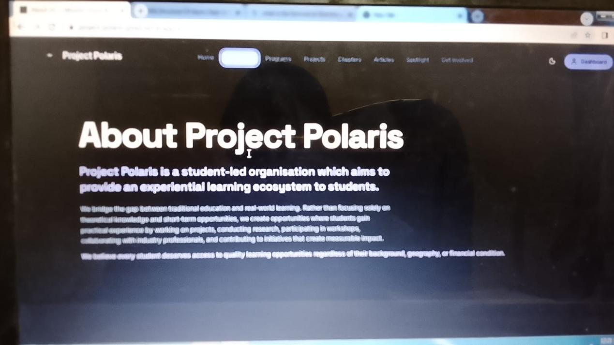
this part isn’t visible
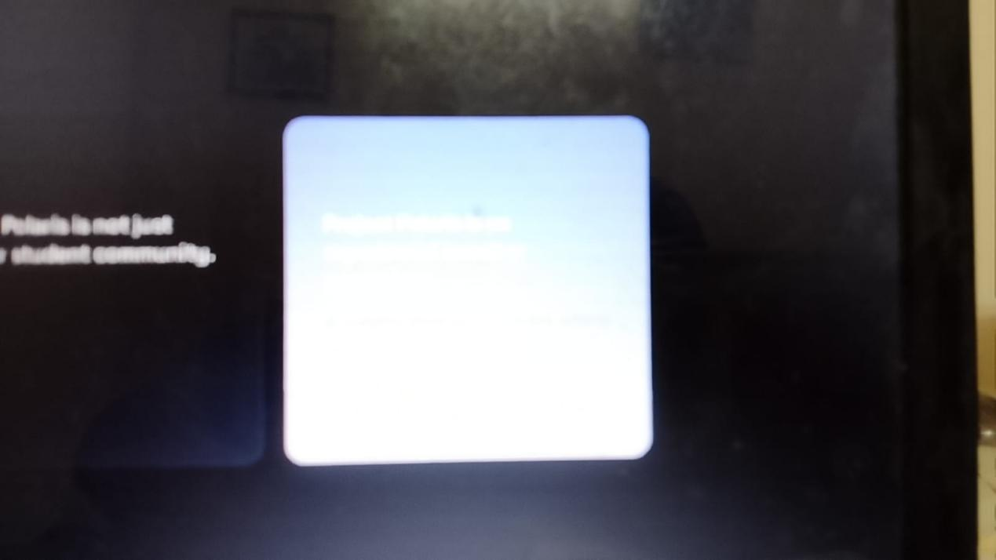
polaris learning methodology image should come here
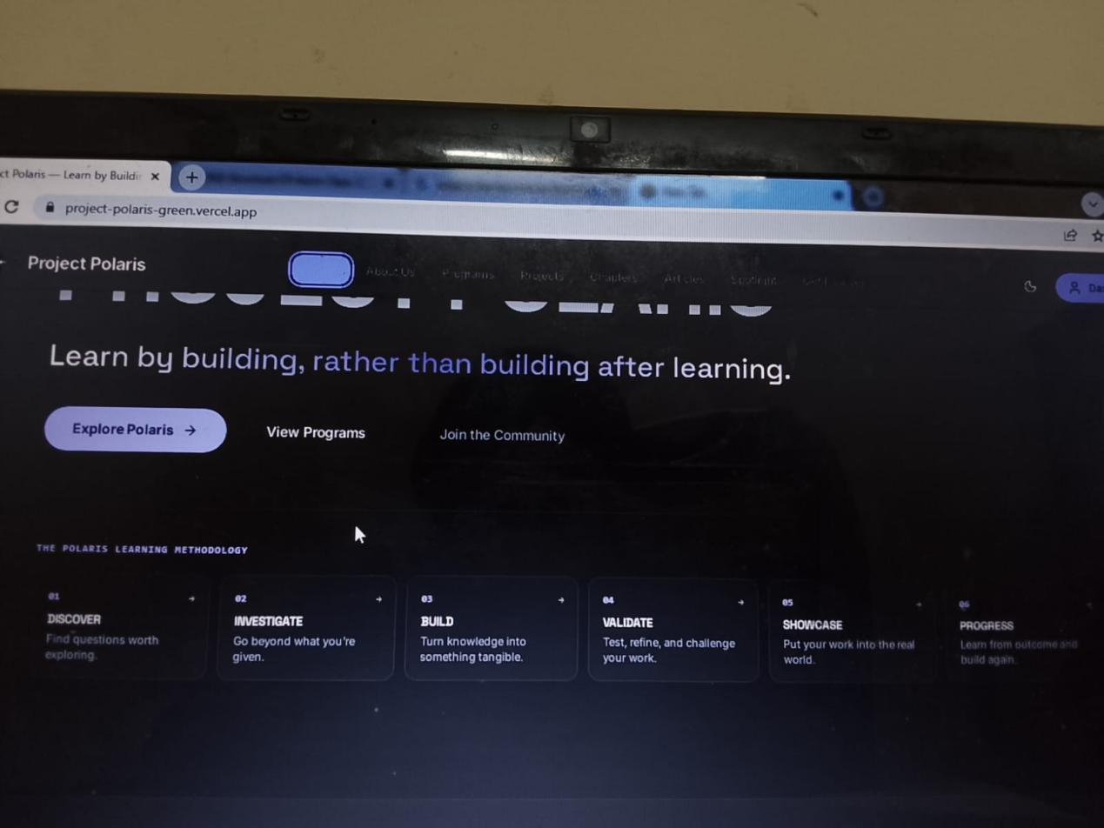
I mean all the images here should come in the respective sections not by creating a different section of Visual framework
make sure the images are in the place of sections that ae existing , and not in a different sections ,

